**Exercise 1: Configuring a Basic Spring Application**

Pom.xml

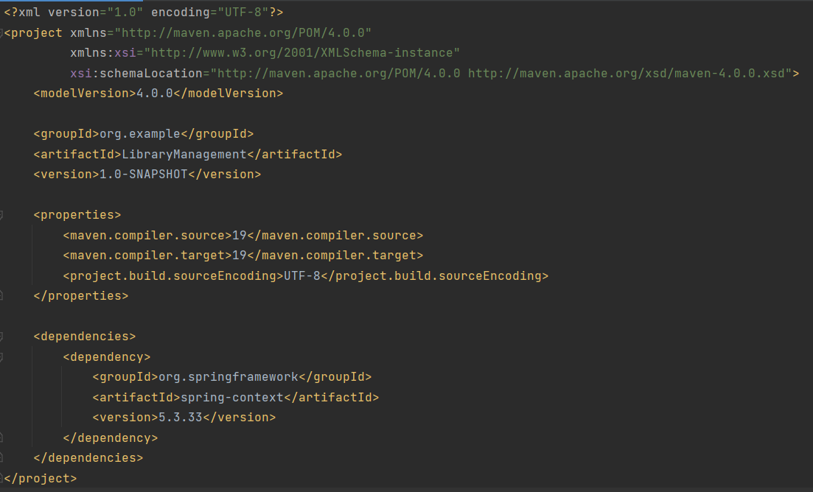

applicationContext.xml

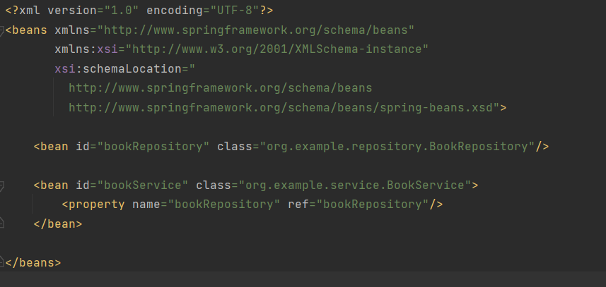

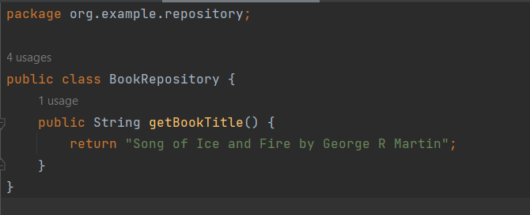

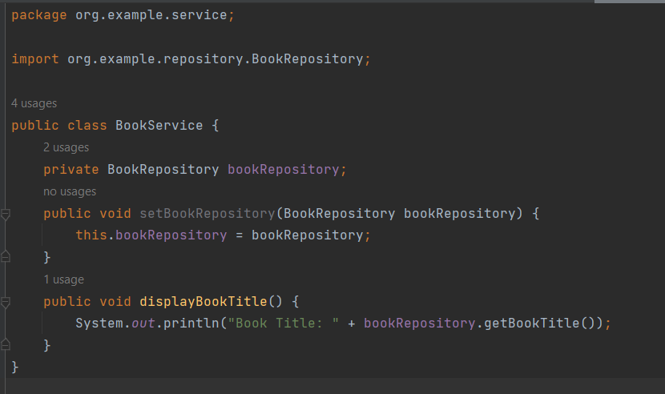

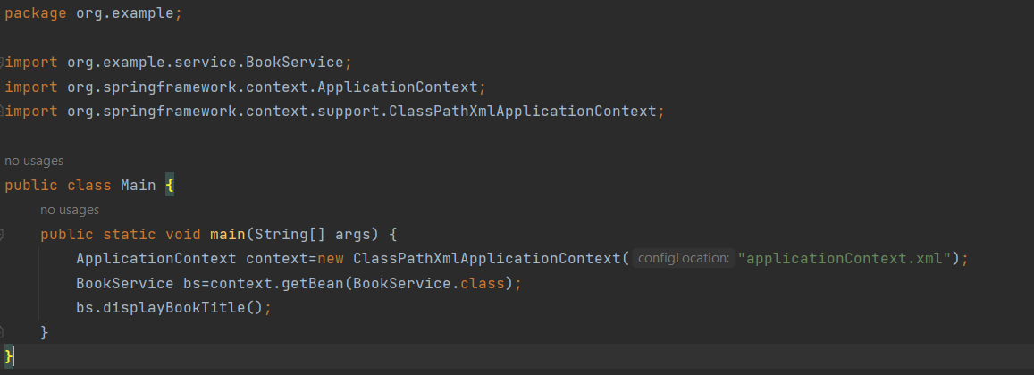

**Output:**

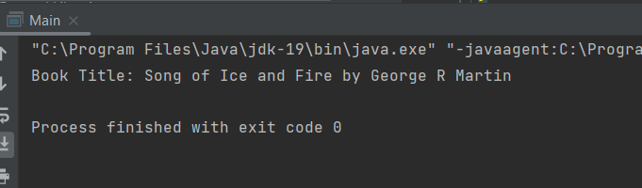

**Exercise 2: Implementing Dependency Injection**







**Output:**



**Exercise 4: Creating and Configuring a Maven Project**

Pom.xml

<?xml version="1.0" encoding="UTF-8"?>  
<project xmlns="http://maven.apache.org/POM/4.0.0"  
 xmlns:xsi="http://www.w3.org/2001/XMLSchema-instance"  
 xsi:schemaLocation="http://maven.apache.org/POM/4.0.0 http://maven.apache.org/xsd/maven-4.0.0.xsd">  
 <modelVersion>4.0.0</modelVersion>  
  
 <groupId>org.example</groupId>  
 <artifactId>LibraryManagement</artifactId>  
 <version>1.0-SNAPSHOT</version>  
  
 <properties>  
 <maven.compiler.source>19</maven.compiler.source>  
 <maven.compiler.target>19</maven.compiler.target>  
 <project.build.sourceEncoding>UTF-8</project.build.sourceEncoding>  
 </properties>  
 <dependencies>  
 <dependency>  
 <groupId>org.springframework</groupId>  
 <artifactId>spring-context</artifactId>  
 <version>5.3.33</version>  
 </dependency>  
  
 <dependency>  
 <groupId>org.springframework</groupId>  
 <artifactId>spring-aop</artifactId>  
 <version>5.3.33</version>  
 </dependency>  
  
 <dependency>  
 <groupId>org.springframework</groupId>  
 <artifactId>spring-webmvc</artifactId>  
 <version>5.3.33</version>  
 </dependency>  
  
 <dependency>  
 <groupId>javax.servlet</groupId>  
 <artifactId>javax.servlet-api</artifactId>  
 <version>4.0.1</version>  
 <scope>provided</scope>  
 </dependency>  
 </dependencies>  
 <build>  
 <plugins>  
 <plugin>  
 <groupId>org.apache.maven.plugins</groupId>  
 <artifactId>maven-compiler-plugin</artifactId>  
 <version>3.8.1</version>  
 <configuration>  
 <source>1.8</source>  
 <target>1.8</target>  
 </configuration>  
 </plugin>  
 </plugins>  
 </build>  
</project>

**Output:**

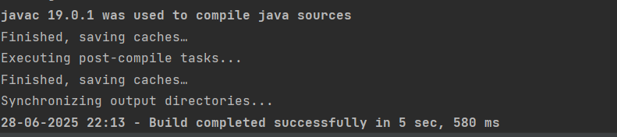

**Exercise 5: Configuring the Spring IoC Container**



**Exercise 7: Implementing Constructor and Setter Injection**

applicationContext.xml

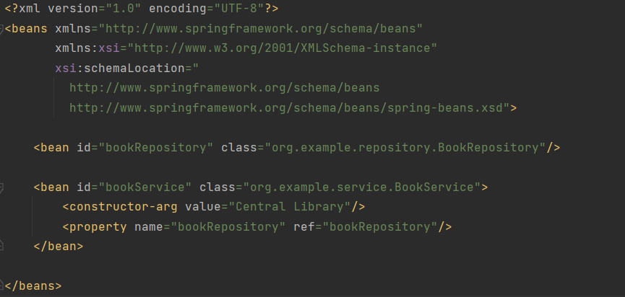

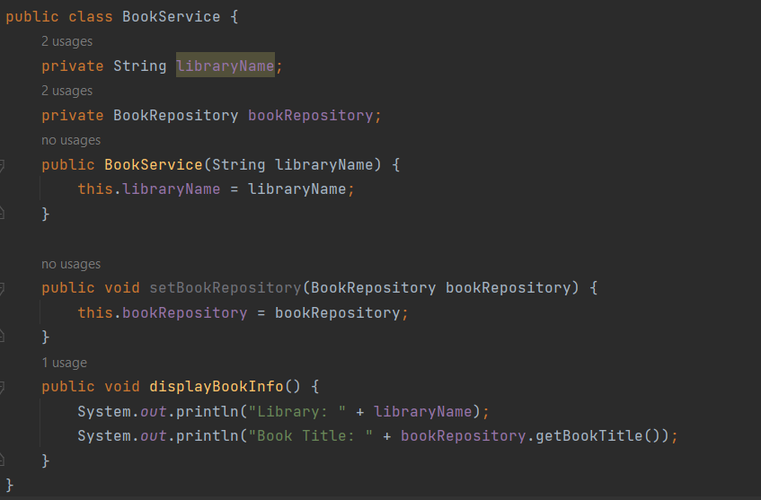

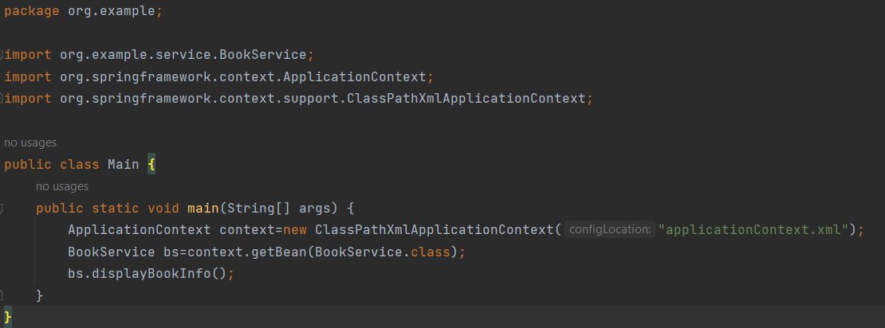

**Output:**

